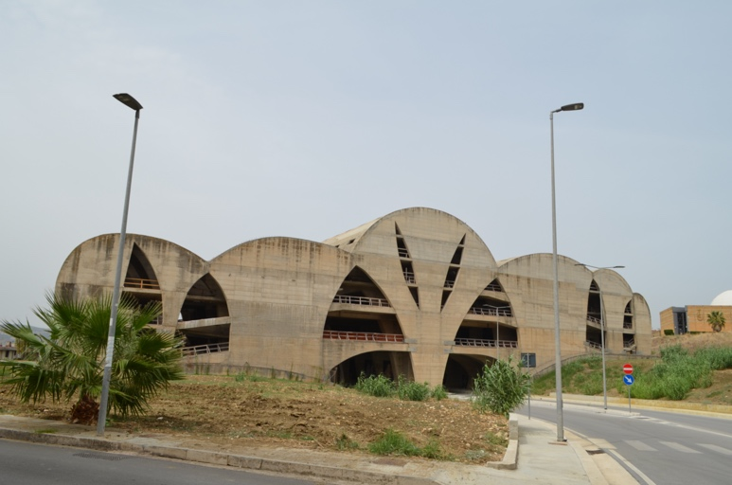
Figure 1. Pietro Consagra, Teatro Frontale, 1984, Gibellina Nuova. Photo Laura Pierini.

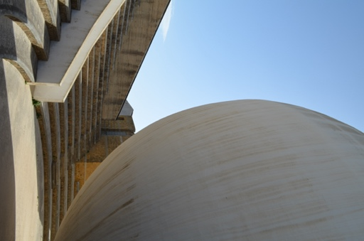

Figure 2. Ludovico Quaroni, Chiesa Madre, 1972, Gibellina Nuova. Photo Laura Pierini.
Age
13-30 | 8
31-50 | 6
51-75 | 4
Gender
Male | 13
Female | 5

Table 1. Gender distribution and age group of participants in the first workshop series, April 2024

Age | Place of birth | Place of residence | Profession
14 | Gibellina | Gibellina Nuova | Student
15 | Gibellina | Gibellina Nuova | Student
16 | Gibellina | Gibellina Nuova | Student
27 | Gibellina | Gibellina Nuova | Unemployed
27 | Gibellina | Gibellina Nuova | Waiter
28 | Gibellina | Gibellina Nuova | Employee
31 | Gibellina | Gibellina Nuova | Volunteer
31 | Gibellina | Gibellina Nuova | Student
34 | Gibellina | Gibellina Nuova | Employee
36 | Gibellina | Gibellina Nuova | Teacher
45 | Gibellina | Gibellina Nuova | Employee
46 | Gibellina Shantytown | Gibellina Nuova | Shopkeeper
50 | Gibellina Shantytown | Gibellina Nuova | Labourer
52 | Gibellina Shantytown | Gibellina Nuova | Labourer
67 | Salemi | Gibellina Nuova | Retired
67 | Gibellina Shantytown | Gibellina Nuova | Farmer
76 | Gibellina Shantytown | Gibellina Nuova | Retired

Table 2. Sociodemographic characteristics of participants (residence, place of origin, and profession) in the first workshop series, April 2024.

Sensitive cartography | Inv. nr. | Author’s comment | Mentioned artworks
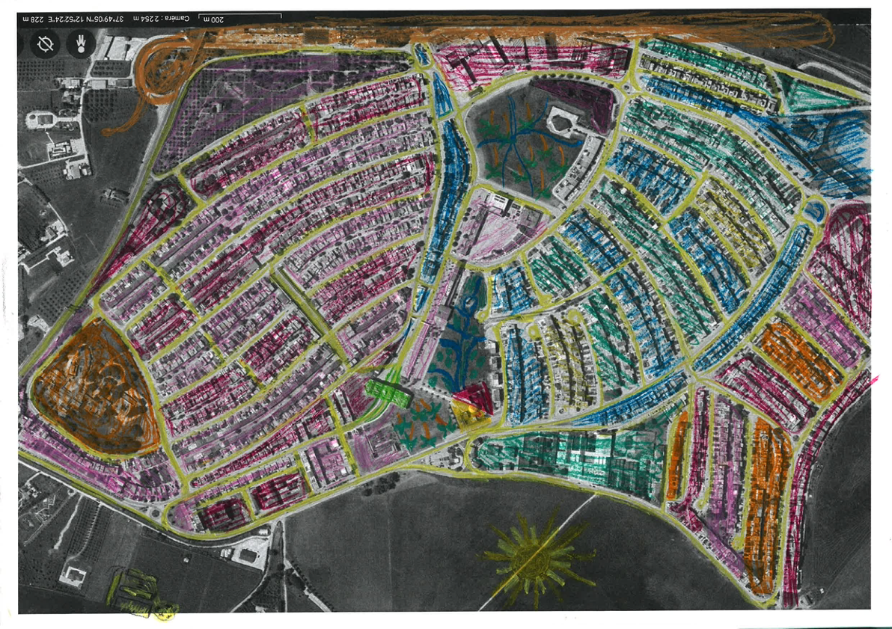 | CS_005 | The map features both places associated with the subject's childhood and idealized locations: imaginary green spaces envisioned for their city, consisting of carefully maintained gardens. | Chiesa Madre,  Teatro Frontale
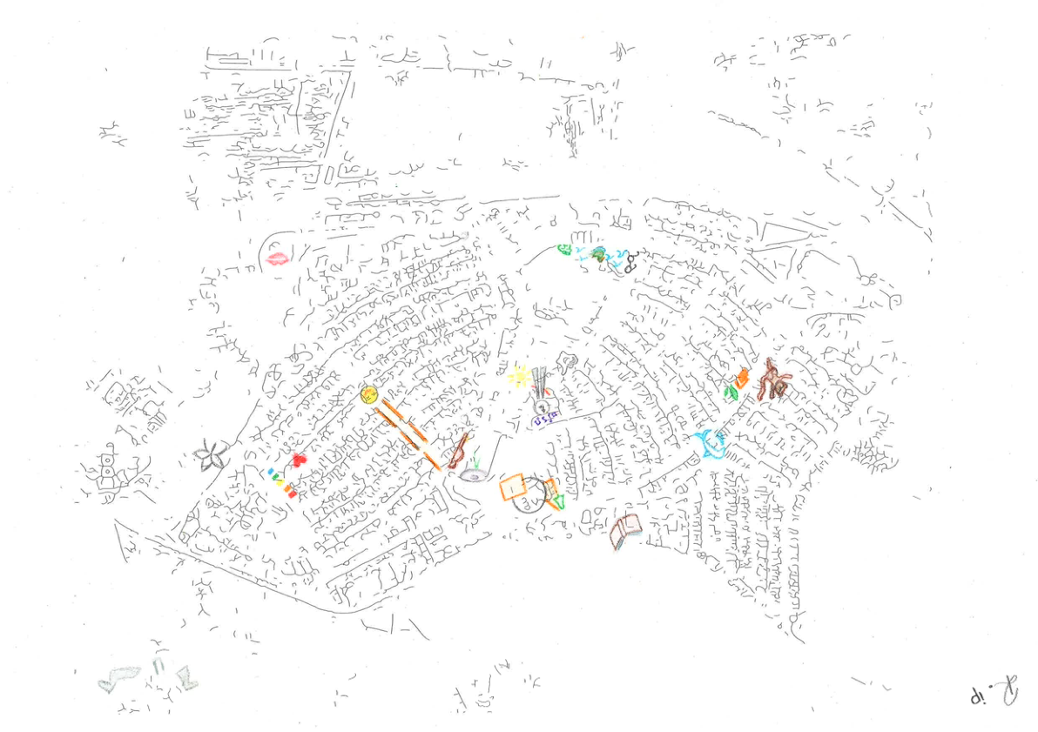 | CS_022 | The map highlights significant places from the subject's childhood as well as locations particularly dear to them, such as their home and the "Giardino Segreto," where carefree moments were experienced. | Sistema delle Piazze, Meeting, Chiesa Madre, Teatro Fontale, Torre Civica, Giardino Segreto 2.
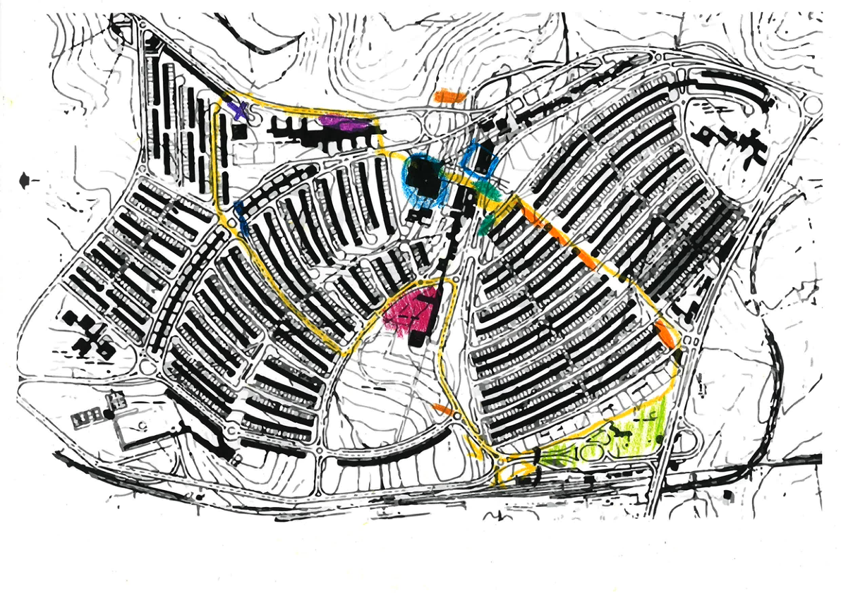 | CS_001 | The map highlights the subject's daily leisure and work routes, intersecting with the "Sistema delle Piazze," the city's central square, and the "Chiesa Madre," marked as a point of interest. The botanical garden is also featured as a green space. | Chiesa Madre, Sistema delle Piazze, Teatro Frontale.
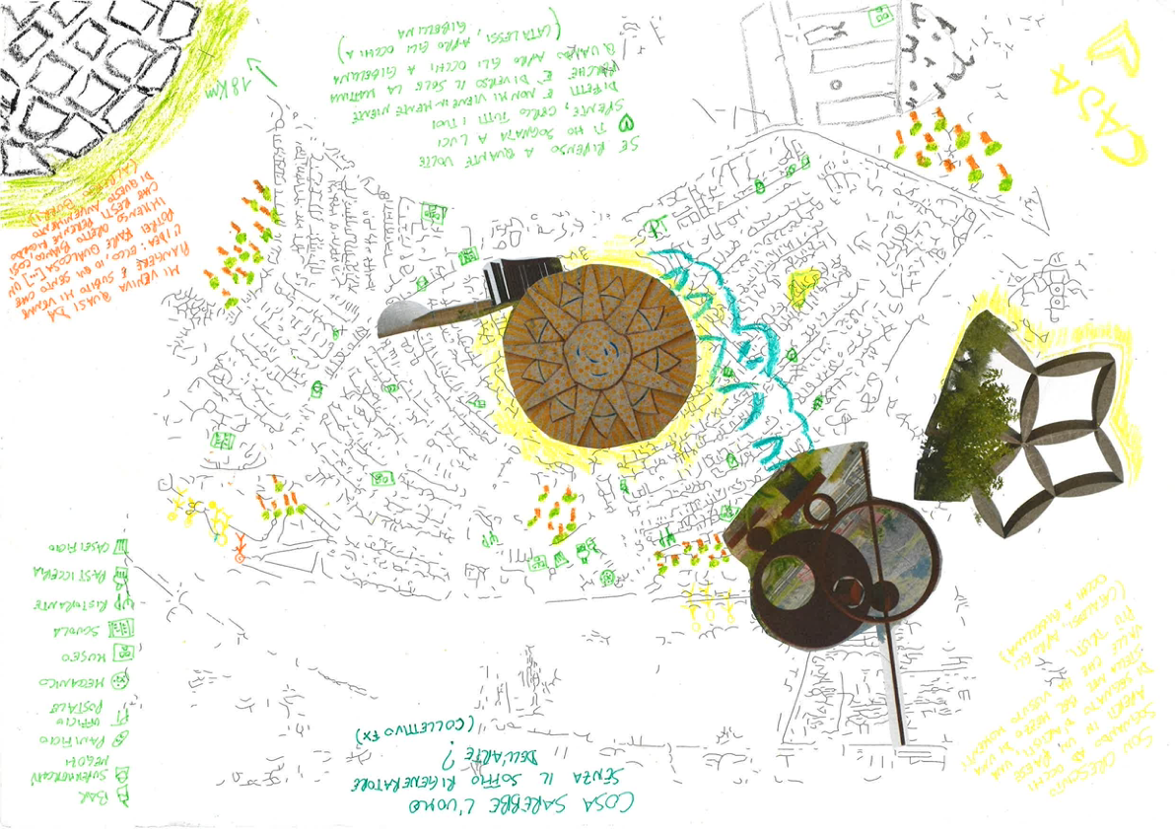 | CS_007 | This map incorporates quotes from a song evoking Gibellina and childhood memories. Using a legend, points of interest in the city (bars, museums, bakeries, post office, etc.) are identified, and major artworks are represented. Green spaces are also highlighted. | Stella del Belice, Omaggio a Tommaso Campanella, Ellittica e Meridiana, Cretto.
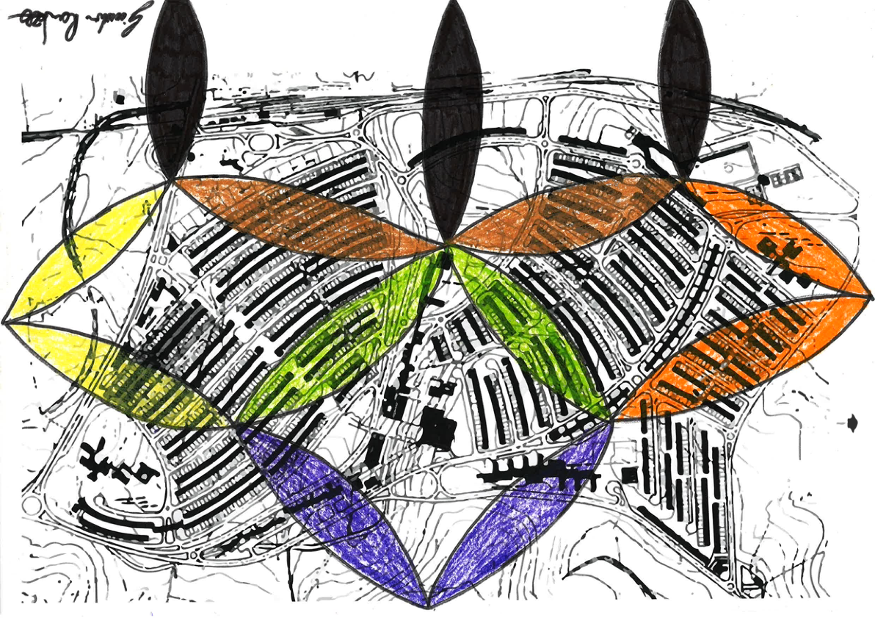 | CS_010 | The map is dominated by the "Stella di Belice," a central and symbolic landmark for the inhabitants of Gibellina. | Stella del Belice.
Table 3. Examples of sensitive cartographies created during the first workshop series in April 2024.

Table 4. Recurrence of artworks cited in the sensitive cartographies created in April 2024.
Age
13-30 | 12
31-50 | 0
51-75 | 2
Gender
Male | 5
Female | 9

Table 5. Gender distribution and age group of participants in the first workshop series. September 2024.

Age | Place of origin | Place of residence | Profession
19 | Gibellina | Gibellina Nuova | Student
19 | Salemi | Salemi | Student
20 | Gibellina | Gibellina Nuova | Student
20 | Gibellina | Gibellina Nuova | Student
21 | Gibellina |  | Student
22 | Salemi | Salemi | Student
23 | Salemi | Salemi | Student
24 | Gibellina | Gibellina Nuova | Student
24 | Alcamo | Alcamo | Student
25 | Salemi | Salemi | Student
25 | Gibellina | Gibellina Nuova | Student
26 | Gibellina | Gibellina Nuova | Student
32 | Gibellina | Gibellina Nuova | Volunteer
57 | Vita | Vita | Employee
62 | Gibellina Shantytown | Gibellina Nuova | Employee
Table 6. Sociodemographic characteristics of participants (residence, place of origin, and profession) in the first workshop series, September 2024.

Mental map | Inv. Nr. | Author’s comment | Mentioned artworks
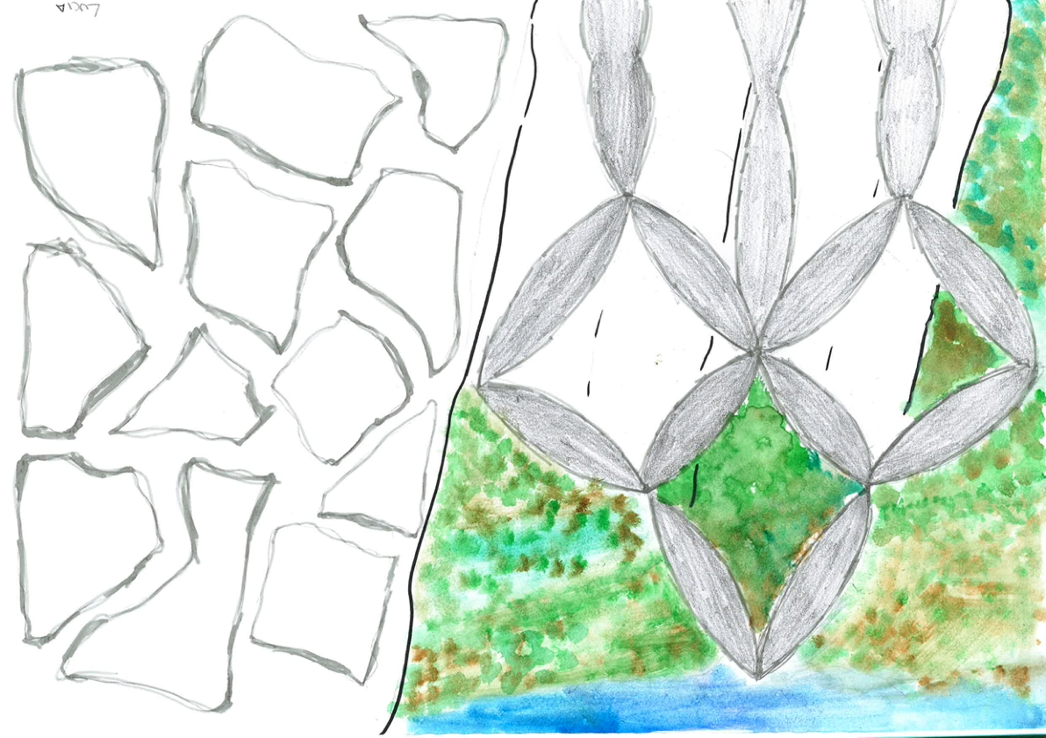 | CM_008 | This drawing combines the old city of Gibellina and the new one through two distinct symbols, chosen to represent each of these eras. | Cretto, Stella del Belice
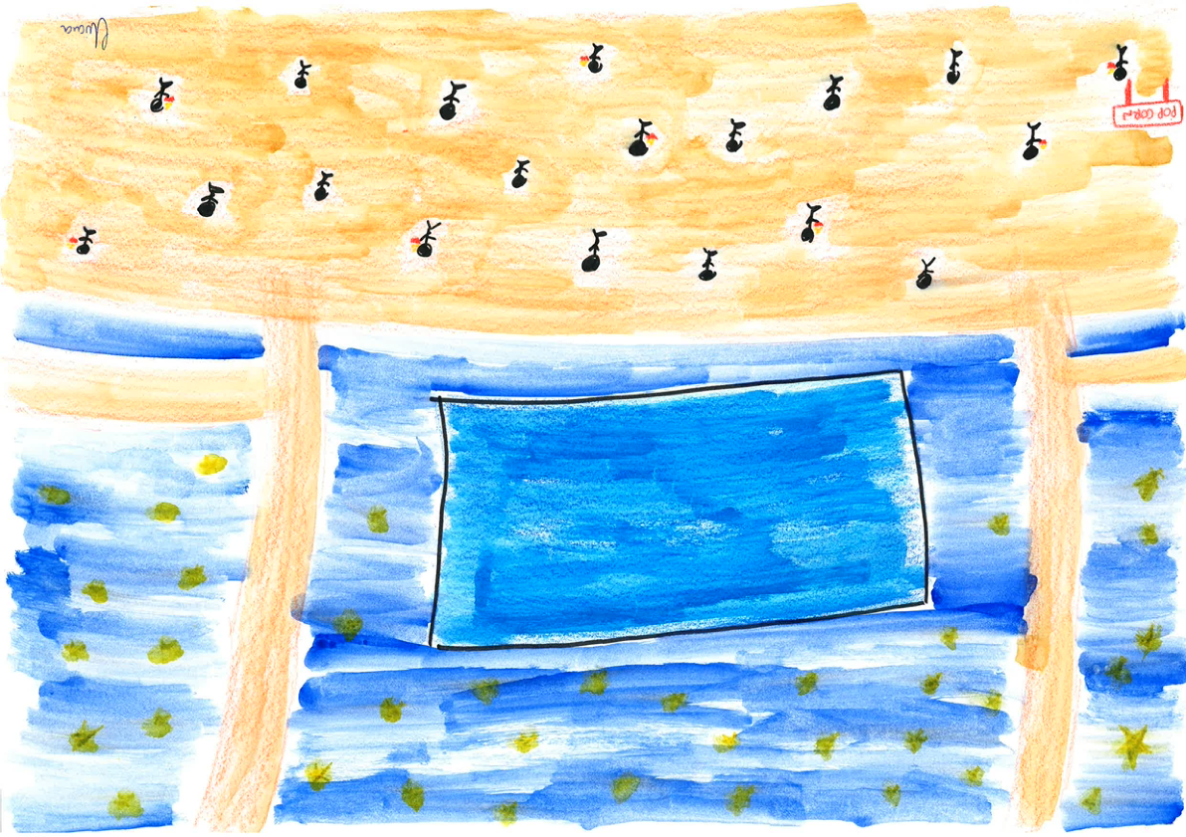 | CM_002 | This drawing represents a cherished memory shared by the author and other participants of the outdoor cinema, held in Gibellina under the stars. | Sisitema delle Piazze
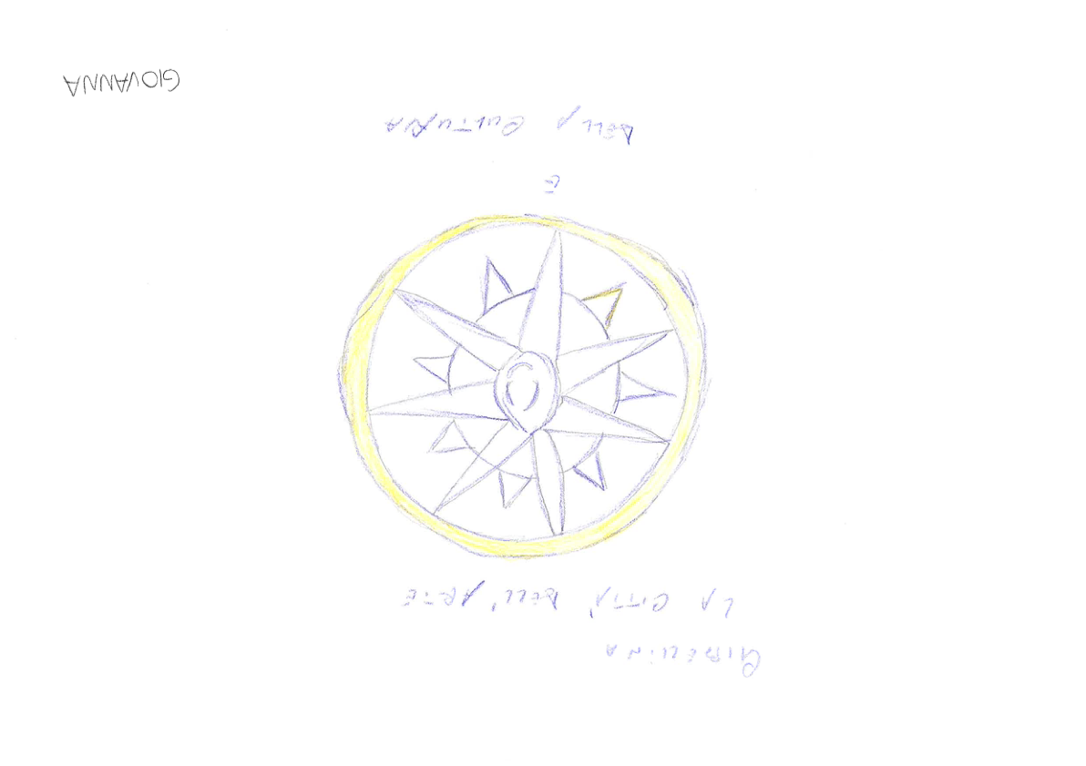 | CM_006 | This drawing represents a work that the author sees daily on her way to work, symbolizing for her the hope of a radiant Gibellina. | Omaggio a Tommaso Campanella
Table 7. Examples of mental maps created during the September 2024 workshop.

Table 8. Recurrence of artworks cited in sensitive mapping carried out in the second workshop series. September 2024.

